<https://learn.microsoft.com/en-us/azure/virtual-network/virtual-networks-overview>

In azure we can rent out the server(resources). Those resources are available in azure data center > availability zone.

Suppose, two candidate requested resources then-

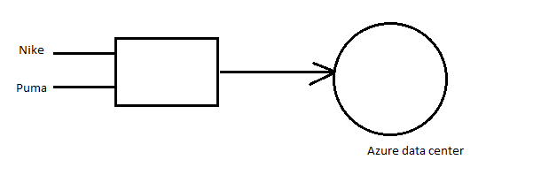

The basic principle of networking in within same network resource can access to each other, so here security is compromised. To solve this security concern Azure introduced VNET(Virtual network)

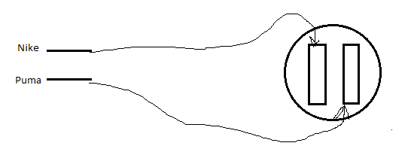

Now, security issue is solved. We have isolation between Nike and Puma. [Public cloud concepts]

Subnets: resources within network can be public or private. For private resource we will create private subnet, and for public resource will create public subnet.

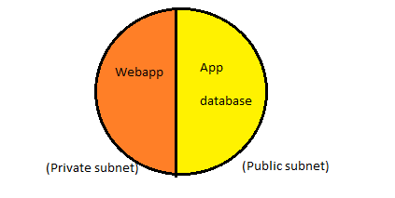

How to define size of virtual network? By CIDR range

Note: In each subnet you can apply security rules, those rules are known as NSG(Network security group)

NSG for Jenkins where we are opening port 8080.

Example of NSG:

1) DB shouldn’t be accessed by internet

2) DB can be accessed by App service.

ASG:

ASG enhances the functionality of NSG like creating rule group of App service can access the DB.

Route table: It define how traffic is flowing within subnet.